PROJECT : BLACKJACK SLOT MACHINE

SCHOOL :

GROUP MEMBERS :

Introduction
Blackjack is a casino banked game, meaning that players compete against the house rather than each other. The objective is to get a hand total of closer to 21 than the dealer without going over 21 (busting). At the start of a Blackjack game, the players and the dealer receive two cards each. After the dealer has shuffled a player will be selected at random and asked to take the card and place it at a random position within stack of cards. The dealer will then move the cards above the cut card to the back of the stack.
Program Analysis
The blackjack program will ask you to key in your account details in which your records will be pulled from. Next you will be asked to place your bet ranging from 0 to the amount in your account. The computer acting as the dealer will deal two cards to you and to itself. Objective of the game being to get as close as you can to value 21. If you go over 21 you lose unless the dealer goes beyond 21 in which case you tie.
When you dealt your initial two cards, you are shown one of the dealers card which helps you determine if you will Hit or Stand. If you Hit, you will be dealt another card otherwise if you Stand the dealer will begin to play his hand.
The dealer must take a hit until the the total points in its hand is 17 or over, at which point it must stay. When both you and the dealer has finished playing your hands, the total number of points acquired by each is used to determine the winner.
Functions and Variables
getBets()
This function is used to get the bet amounts from the player. The player will be prompted to input how much they want to stake. The amount staked will be deducted from the bank of the current player.

dealCards()
This function is used to deal the cards for the player and dealer.

checkBlackjack()
This function is is responsible for performing initial checking for who has the blackjack between the player and the dealer using if…else to determine loser and winner.

hitOrStand()
When the value of cards is less than 21 for either the dealer or player, the player will be prompted with Hit or Stand options.

printMoney()
This function is used to display the bank account status of the player. It validates if the player has enough money to place the stated bet.

playAgain()
Incase of loss of game, the player will be prompted to choose if they will play again or not. If yes, they will input “Y” otherwise “N”.

endGame()
When the player no longer desires to continue, the game will be terminated and the respective player account updated.

Blackjack.java
This shows the codes used to initialize the program upon launch.
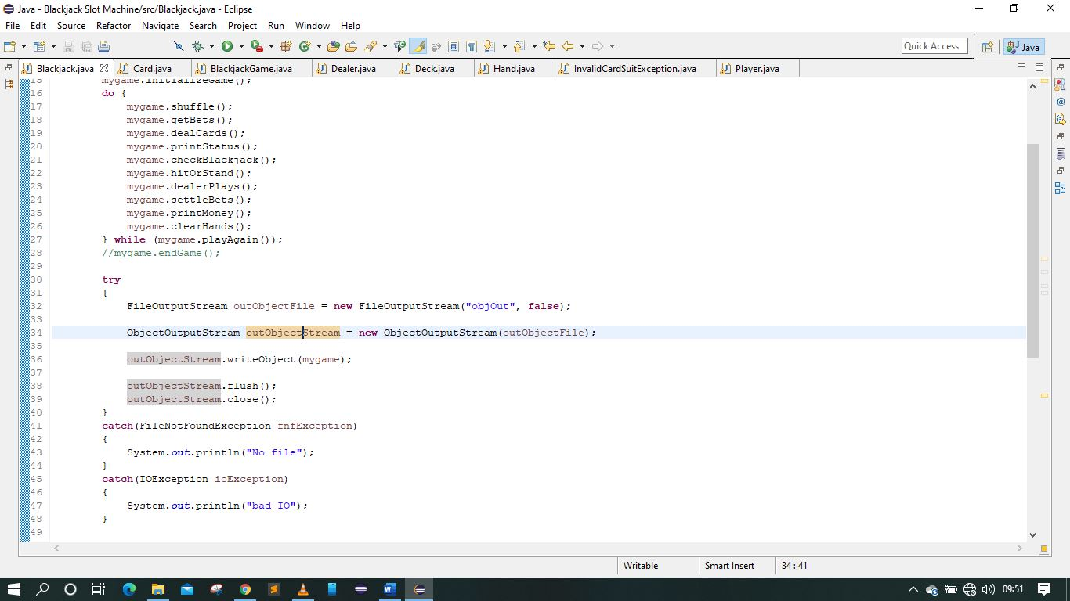

BlackjackGame.java
On launch theprogram will display a welcome message. At this point the user will be required to key in there various info before the game begins
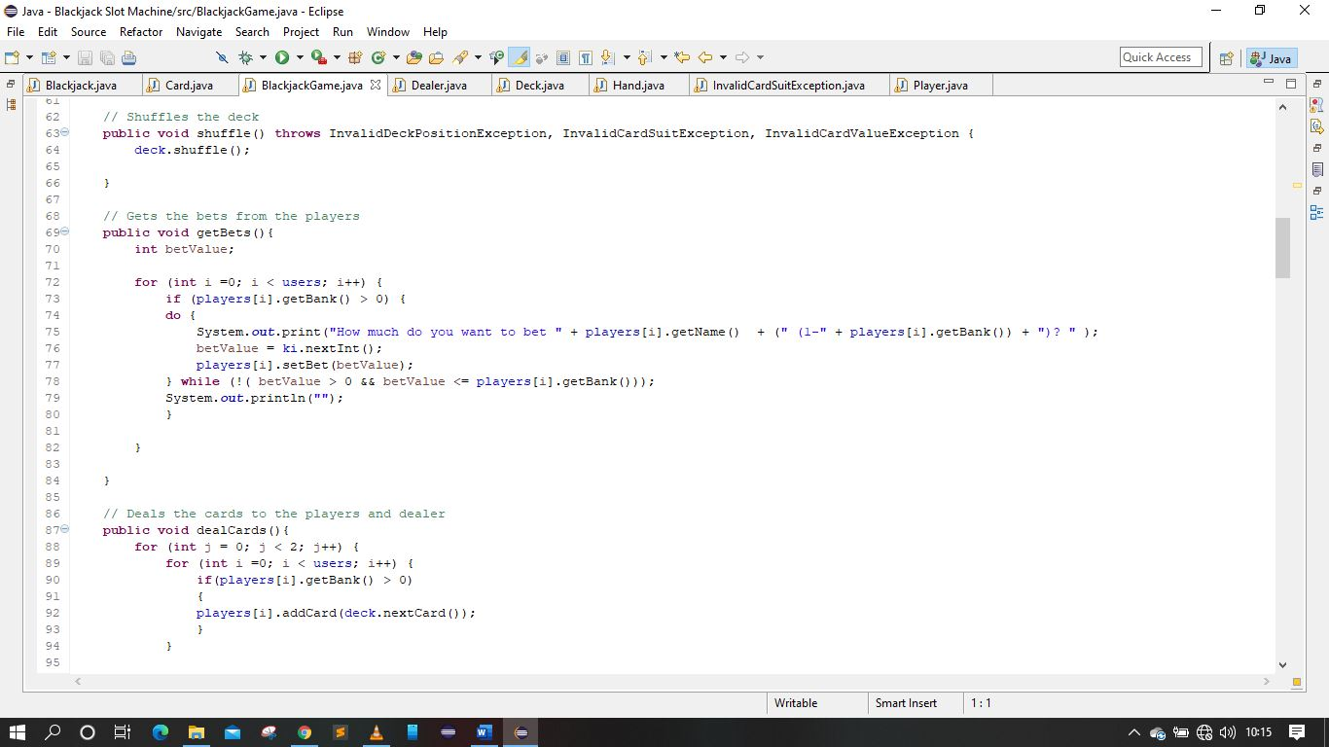

Player.java
The account details will be loaded and the balance set at the start of new game. It will be updated with each game played.
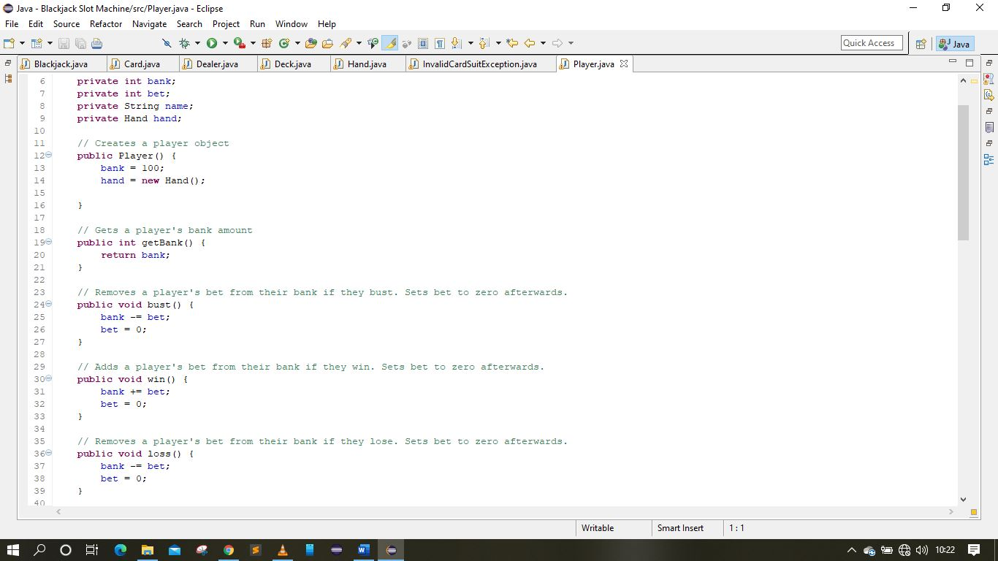
Deck.java
The card deck is loaded with the card and there respective values
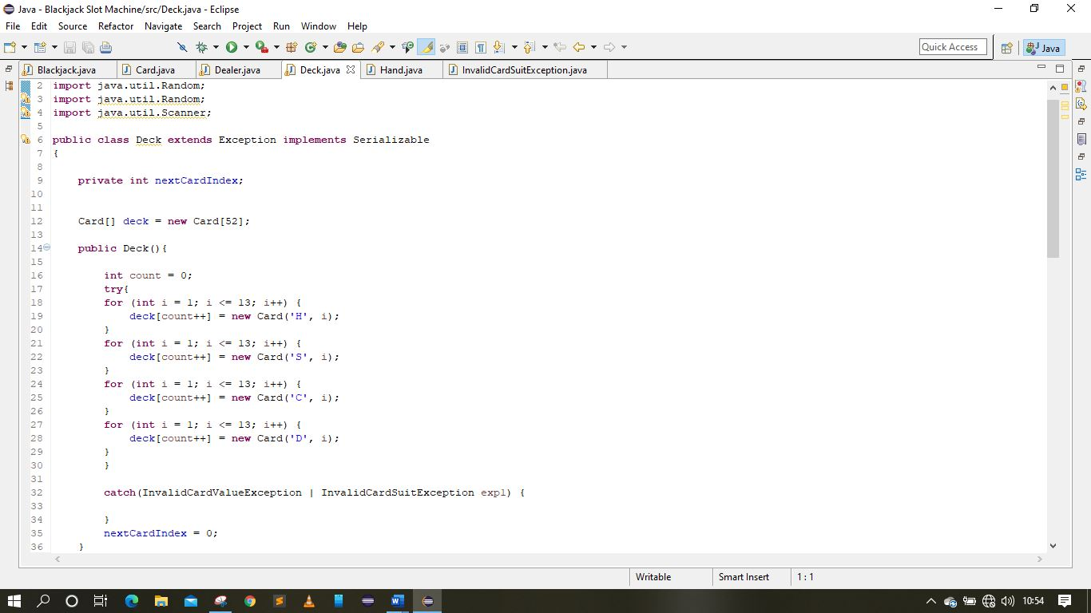

Card.java
The respective card values are assigned to each of the cards
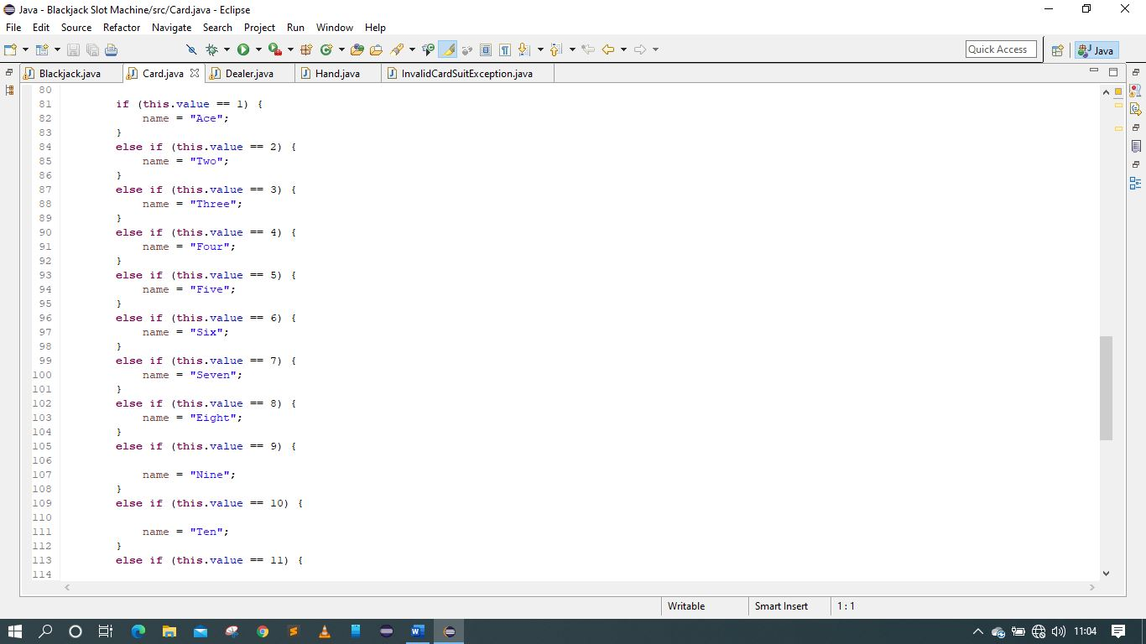

Sample Run
Input of details
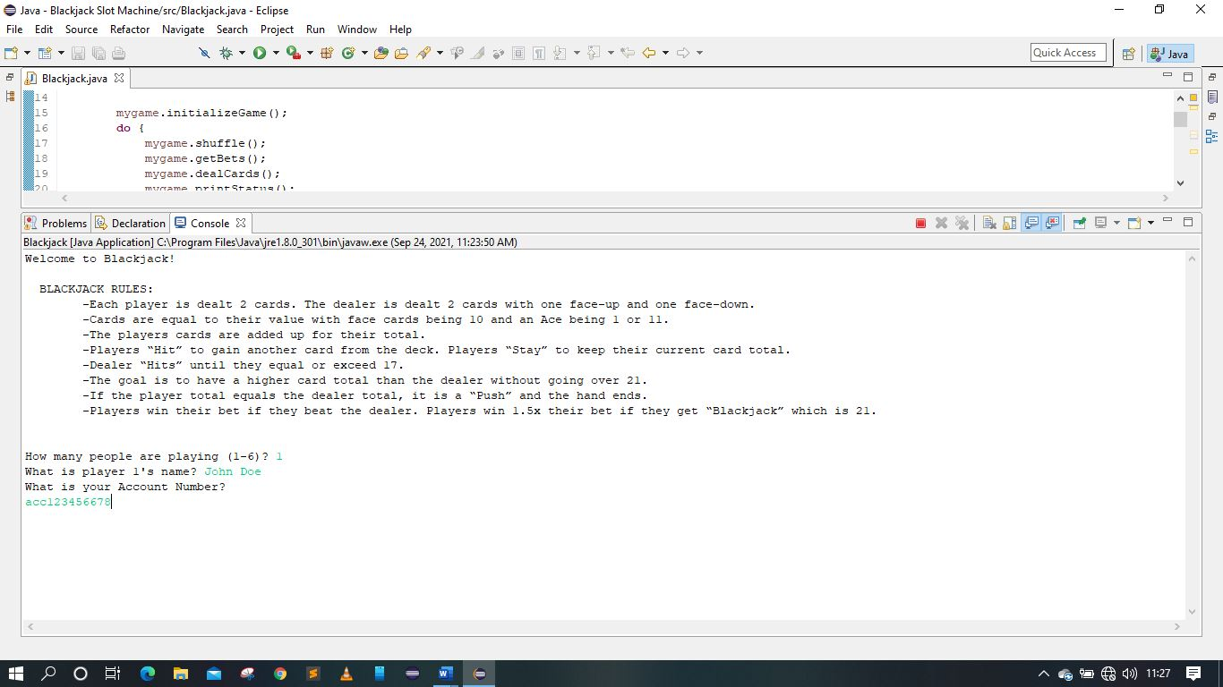

On playing till winning
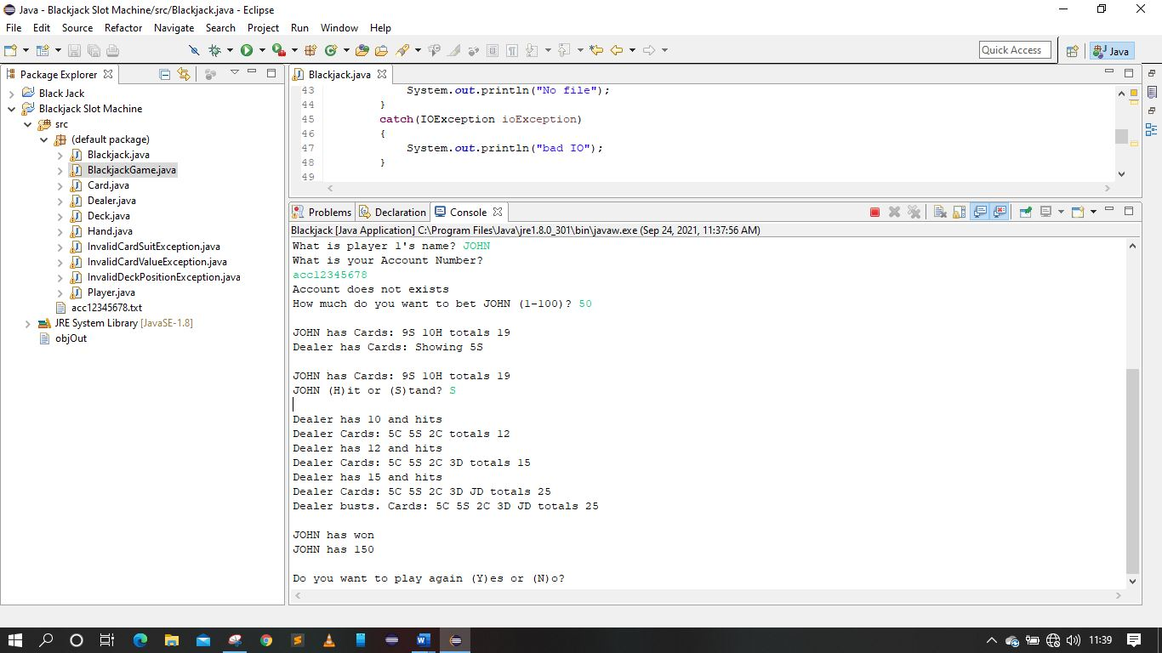

Loss
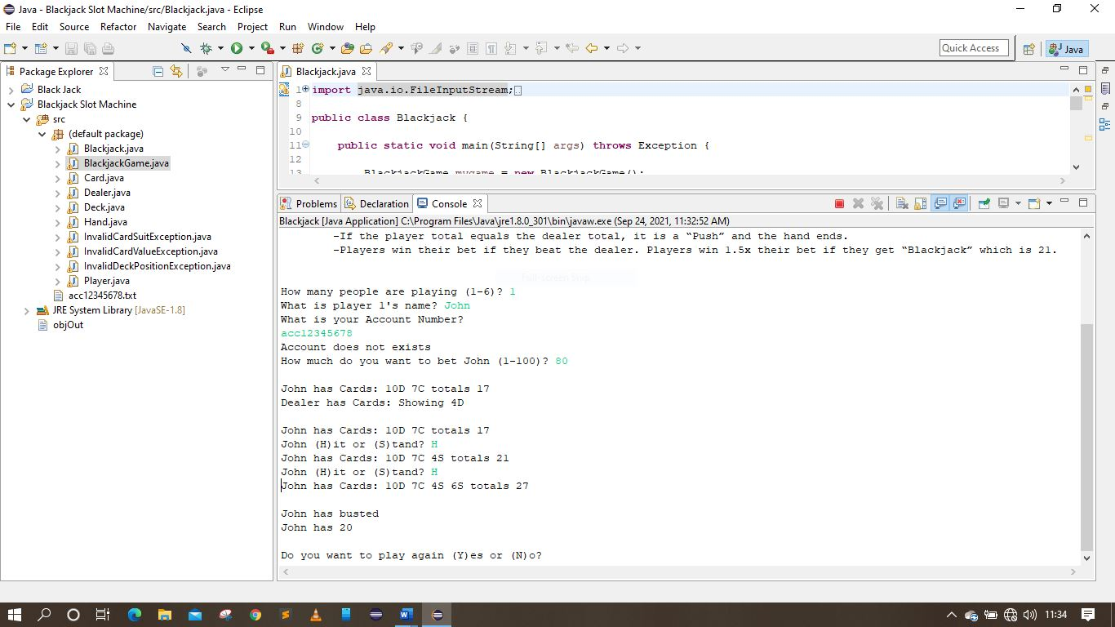

Insufficient Account balance
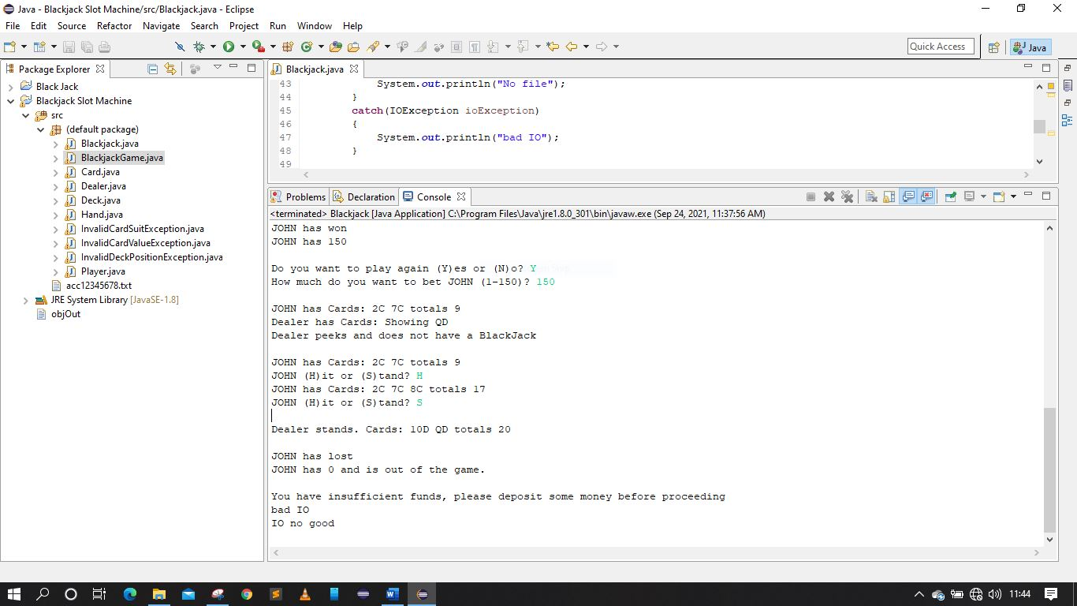

UML Diagram
Game
dealer
player
log
open()
close()
run()
history()
is_finished()
Dealer
name
budget
hand
state
strategy
deck
shuffle()
Deck
cards
shuffle()
draw_card()
Card
rank
suit
value()
Player
name
budget
hand
state
strategy
hit()
stand()
Hand
cards
soft
add(card)
value()
string

